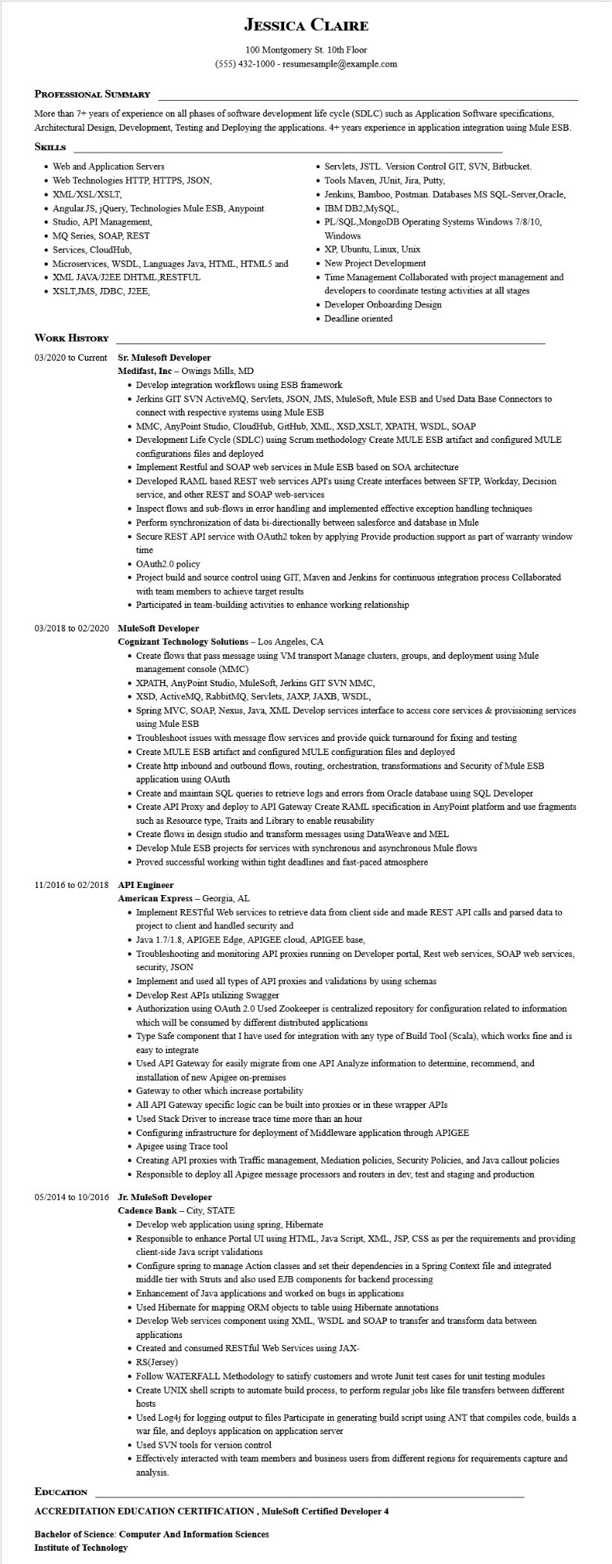
JESSICA CLAIRE
100 Montgomery St. 10th Floor
(555) 432-1000 - resumesample@example.com
PROFESSIONAL SUMMARY
More than 7+ years of experience on all phases of software development life cycle (SDLC) such as Application Software specifications, Architectural Design, Development, Testing and Deploying the applications. 4+ years experience in application integration using Mule ESB. SKILLS
• Web and Application Servers
• Web Technologies HTTP, HTTPS, JSON,
• XML/XSL/XSLT,
• Angular JS, jQuery, Technologies Mule ESB, Anypoint
• Studio, API Management,
• MQ Series, SOAP, REST
• Services, CloudHub,
• Microservices, WSDL, Languages Java, HTML, HTML5 and
• XML JAVA/J2EE DHTML.RESTFUL
• XSLT,JMS, JDBC, J2EE,
⚫ Servlets, JSTL. Version Control GIT, SVN, Bitbucket. • Tools Maven, JUnit, Jira, Putty,
• Jenkins, Bamboo, Postman. Databases MS SQL-Server, Oracle, • IBM DB2.MySQL,
• PL/SQL,MongoDB Operating Systems Windows 7/8/10,
Windows
• XP, Ubuntu, Linux, Unix
• New Project Development
• Time Management Collaborated with project management and developers to coordinate testing activities at all stages • Developer Onboarding Design
• Deadline oriented
WORK HISTORY
03/2020 to Current
Sr. Mulesoft Developer
Medifast, Inc - Owings Mills, MD
• Develop integration workflows using ESB framework
• Jerkins GIT SVN ActiveMQ, Servlets, JSON, JMS, MuleSoft, Mule ESB and Used Data Base Connectors to connect with respective systems using Mule ESB
• MMC, AnyPoint Studio, CloudHub, GitHub, XML, XSD, XSLT, XPATH, WSDL, SOAP
• Development Life Cycle (SDLC) using Scrum methodology Create MULE ESB artifact and configured MULE configurations files and deployed
• Implement Restful and SOAP web services in Mule ESB based on SOA architecture
• Developed RAML based REST web services API's using Create interfaces between SFTP, Workday, Decision service, and other REST and SOAP web-services
• Inspect flows and sub-flows in error handling and implemented effective exception handling techniques
• Perform synchronization of data bi-directionally between salesforce and database in Mule
• Secure REST API service with OAuth2 token by applying Provide production support as part of warranty window time
• OAuth2.0 policy
• Project build and source control using GIT, Maven and Jenkins for continuous integration process Collaborated with team members to achieve target results
• Participated in team-building activities to enhance working relationship
03/2018 to 02/2020 MuleSoft Developer
Cognizant Technology Solutions - Los Angeles, CA
• Create flows that pass message using VM transport Manage clusters, groups, and deployment using Mule management console (MMC)
• XPATH, AnyPoint Studio, MuleSoft, Jerkins GIT SVN MMC,
• XSD, ActiveMQ, RabbitMQ, Servlets, JAXP, JAXB, WSDL,
• Spring MVC, SOAP, Nexus, Java, XML Develop services interface to access core services & provisioning services using Mule ESB
• Troubleshoot issues with message flow services and provide quick turnaround for fixing and testing
• Create MULE ESB artifact and configured MULE configuration files and deployed
• Create http inbound and outbound flows, routing, orchestration, transformations and Security of Mule ESB application using OAuth
• Create and maintain SQL queries to retrieve logs and errors from Oracle database using SQL Developer
• Create API Proxy and deploy to API Gateway Create RAML specification in AnyPoint platform and use fragments such as Resource type, Traits and Library to enable reusability
• Create flows in design studio and transform messages using Data Weave and MEL
• Develop Mule ESB projects for services with synchronous and asynchronous Mule flows
• Proved successful working within tight deadlines and fast-paced atmosphere
11/2016 to 02/2018 API Engineer
American Express - Georgia, AL
• Implement RESTful Web services to retrieve data from client side and made REST API calls and parsed data to project to client and handled security and
• Java 1.7/1.8, APIGEE Edge, APIGEE cloud, APIGEE base,
• Troubleshooting and monitoring API proxies running on Developer portal, Rest web services, SOAP web services, security, JSON
• Implement and used all types of API proxies and validations by using schemas
• Develop Rest APIs utilizing Swagger
• Authorization using OAuth 2.0 Used Zookeeper is centralized repository for configuration related to information which will be consumed by different distributed applications
• Type Safe component that I have used for integration with any type of Build Tool (Scala), which works fine and is easy to integrate
• Used API Gateway for easily migrate from one API Analyze information to determine, recommend, and installation of new Apigee on-premises
• Gateway to other which increase portability
• All API Gateway specific logic can be built into proxies or in these wrapper APIs
• Used Stack Driver to increase trace time more than an hour
• Configuring infrastructure for deployment of Middleware application through APIGEE
• Apigee using Trace tool
• Creating API proxies with Traffic management, Mediation policies, Security Policies, and Java callout policies
• Responsible to deploy all Apigee message processors and routers in dev, test and staging and production
05/2014 to 10/2016 Jr. MuleSoft Developer
EDUCATION
Cadence Bank - City, STATE
• Develop web application using spring, Hibernate
• Responsible to enhance Portal UI using HTML, Java Script, XML, JSP, CSS as per the requirements and providing client-side Java script validations
• Configure spring to manage Action classes and set their dependencies in a Spring Context file and integrated middle tier with Struts and also used EJB components for backend processing
• Enhancement of Java applications and worked on bugs in applications
• Used Hibernate for mapping ORM objects to table using Hibernate annotations
• Develop Web services component using XML, WSDL and SOAP to transfer and transform data between applications
• Created and consumed RESTful Web Services using JAX-
• RS(Jersey)
• Follow WATERFALL Methodology to satisfy customers and wrote Junit test cases for unit testing modules
• Create UNIX shell scripts to automate build process, to perform regular jobs like file transfers between different hosts
• Used Log4j for logging output to files Participate in generating build script using ANT that compiles code, builds a war file, and deploys application on application server
• Used SVN tools for version control
• Effectively interacted with team members and business users from different regions for requirements capture and analysis.
ACCREDITATION EDUCATION CERTIFICATION, MuleSoft Certified Developer 4
Bachelor of Science: Computer And Information Sciences
Institute of Technology

